5 Set Killer Bike Workout
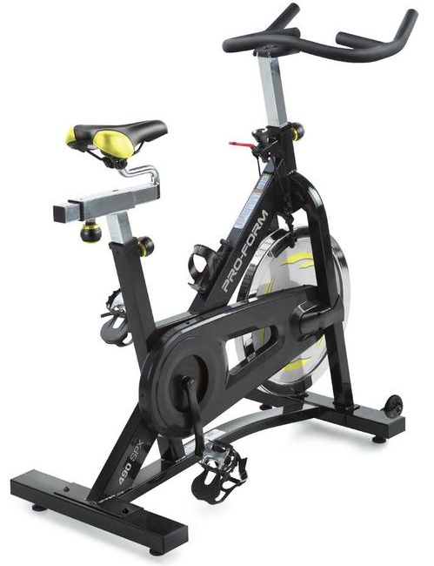
- Set 1
  - GO all out for 20 seconds
  - Then rest 20 seconds
  - Repeat 8 Times
  - Rest 60 seconds before set 2
- Set 2
  - GO all out for 20 seconds
  - Then rest 10 seconds
  - Repeat 8 Times
  - Rest 60 seconds before set 3
- Set 3
  - Repeat set 1
- Set 4
  - Repeat set 2
- Set 5
  - GO all out for 30 seconds
  - Then rest 20 seconds
  - GO all out for 20 seconds
  - Then rest 20 seconds
  - Repeat 4 Times

